Effat University – College of Engineering Department of Computer Science
CS4074: Big Data Analytics Lab 5: Programming with Apache Spark
From SparkSession to Execution Plans — End-to-End PySpark Pipeline
Student Name:
Student ID:
Section:
Date:
Objective: Write, execute, and analyze PySpark programs. Map every operation to the distributed computing architecture, DAG, and memory concepts from the lecture.
Dataset: NYC Yellow Taxi Trip Data — January 2024 (≈3 million rows, 51 MB Parquet) + Zone Lookup Table (265 rows, CSV).
Prerequisites: Lab 4 (Spark RDDs), Lecture 5 (PySpark Programming). Tools: VSCode, PySpark 3.5, Hadoop HDFS, Python 3.8+.
Duration: 3 hours.
Structure: Part 1: Setup (15 min) → Part 2: HDFS (20 min) → Part 3: SparkSession (10 min)
→ Part 4: Ingestion (15 min) → Part 5: DataFrame API (45 min) → Part 6: Spark SQL (20 min) → Part 7: UDFs (15 min) → Part 8: Partitioning (15 min) → Part 9: Caching (10 min) → Part 10: Output (15 min) → Part 11: Execution Plans (15 min) → Deep Work (30 min).

Part 1 Pre-Lab Setup & VSCode (15 min)

1.1 Pre-Lab Checklist
Run each command before starting. All must pass.

Check | Command | Status
Java 11+ installed | java -version | □ Pass
HDFS running | jps (NameNode + DataNode) | □ Pass
PySpark installed | pip show pyspark | □ Pass
VSCode installed | code –version | □ Pass
Python 3.8+ | python3 –version | □ Pass
PyArrow (for Pandas UDFs) | pip show pyarrow | □ Pass
△
HDFS Not Running?
If
jps
does not show
NameNode
and
DataNode
, start HDFS first:
1
start-dfs.sh
# wait 20 seconds
2
# verify both processes appear
jps

1.2 Create Project Folder and Open in VSCode
▶
Terminal
1
mkdir ~/cs4074_lab5 && cd ~/cs4074_lab5
2
mkdir -p data output src
3
code .
# opens VSCode in this folder
Your project structure should look like:
cs4074_lab5/
|-- data/ | <- downloaded files
|-- output/ | <- local backup
‘-- src/ | <- all Python scripts

1.3 Install VSCode Extensions
Open the Extensions panel (Ctrl+Shift+X) and install:

Extension | Purpose
Python (Microsoft) | Language support, IntelliSense
Pylance | Fast type checking and autocompletion
Jupyter | Run .ipynb notebooks inside VSCode
Rainbow CSV | Color-coded CSV preview

1.4 Configure the Python Interpreter
Press Ctrl+Shift+P→ type Python: Select Interpreter → choose the Python 3.8+ environment where PySpark is installed.

1.5 Create the Main Script
Create src/lab5_pipeline.py. Place this header at the top — fill in your name and ID before writing any code:
# CS4074 Lab 5 -- NYC Taxi Analytics Pipeline
# Student Name: ____Jana Mufti____________________________ # Student ID: ______S21106991__________________________ # Date: ________________________________
import os, time from pyspark.sql import SparkSession from pyspark.sql.functions import * from pyspark.sql.types import * from pyspark.sql.window import Window
⋆ Run from Terminal, Not from VSCode Run Button
Always run your script from the terminal inside VSCode (Ctrl+‘) using:
- cd ~/cs4074_lab5
- python src/lab5_pipeline.py
This ensures the HDFS environment variables are correctly inherited.
Part 2 Download Dataset & Load into HDFS (20 min)
You will use the NYC Yellow Taxi Trip Data published by the NYC Taxi & Limousine Commission (TLC) — a real-world public dataset with ≈3 million trips recorded in January 2024.
¶ Why This Dataset?
Real taxi data has the same challenges as enterprise data: null values, negative fares from reversals, outliers, multi-key joins, temporal features, and geospatial IDs. Every cleanup step you do here mirrors production data engineering.

2.1 Download the Files
▶
Terminal — run from ~/cs4074_lab5/data/
1
cd ~/cs4074_lab5/data
2
3
# Main trip data (~51 MB Parquet)
4
wget https://d37ci6vzurychx.cloudfront.net/trip-data/
yellow_tripdata_2024-01.parquet
5
6
# Zone lookup table (~12 KB CSV)
7
wget https://d37ci6vzurychx.cloudfront.net/misc/taxi_zone_lookup.
csv
8
9
# Verify both files
10
ls -lh
Task 2.1 — Record File Information
After downloading, fill in:
- Parquet file size on disk:
- CSV file size on disk:
- Parquet file format: columnar / row-based (circle one)
- Does the Parquet file contain an embedded schema? Yes / No (circle one)
2.1 1/48M/2/13K/3/Columnar/4/Yes/5/
Parquet file size on disk: ~48 MB /CSV file size on disk: ~13 KB /Parquet file format: Columnar/Does the Parquet file contain an embedded schema? Yes

2.2 Create HDFS Directory Structure
▶
Terminal
1
hdfs dfs -mkdir -p /cs4074/lab5/data
2
hdfs dfs -mkdir -p /cs4074/lab5/output
3
4
# Verify directories
5
hdfs dfs -ls /cs4074/
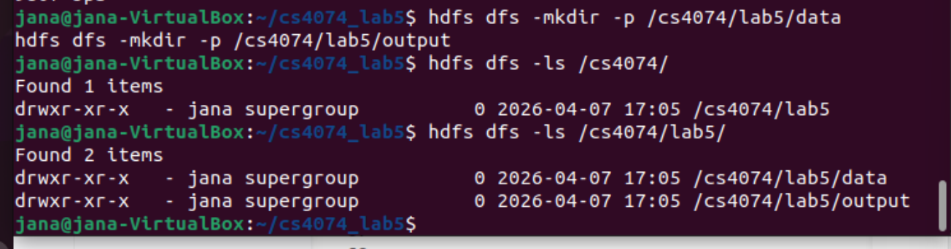
Upload Data to HDFS
2.3
▶
Terminal
1
# Upload Parquet file (may take 15-30 seconds)
2
hdfs dfs -put ~/cs4074_lab5/data/yellow_tripdata_2024-01.parquet \
3
/cs4074/lab5/data/
4
5
# Upload zone lookup CSV
6
hdfs dfs -put ~/cs4074_lab5/data/taxi_zone_lookup.csv \
7
/cs4074/lab5/data/
8
9
# Verify upload
10
hdfs dfs -ls /cs4074/lab5/data/
11
hdfs dfs -du -h /cs4074/lab5/data/
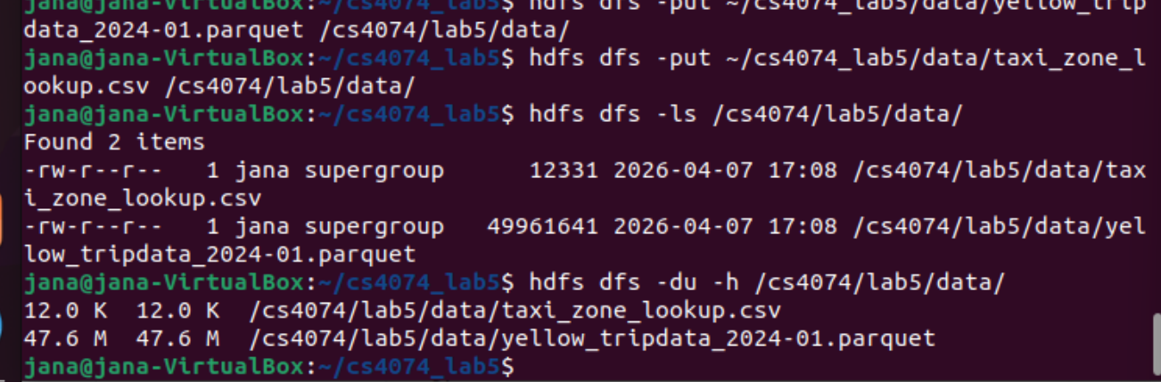

2.4 Verify via Hadoop Web UI
Open http://localhost:9870→ Utilities → Browse File System → navigate to /cs4074/lab5/data/.
Task 2.2 — HDFS Verification Screenshot
Take a screenshot of the Hadoop Web UI showing both files in HDFS.
Paste your Hadoop Web UI screenshot here — show both files in
/cs4074/lab5/data/
♢
Reflection 2.1 — HDFS Blocks
Run the command below and answer the questions:
1
hdfs fsck /cs4074/lab5/data/yellow_tripdata_2024-01.parquet -files
blocks
-
•
How many HDFS blocks does the Parquet file occupy?
•
Each HDFS block is 128 MB. Since
51
MB
<
128
MB, the file occupies
⌈
51
÷
128
⌉
=
block(s). Does this match
fsck
?
•
Predict: how many Spark partitions will be created when we read this file?
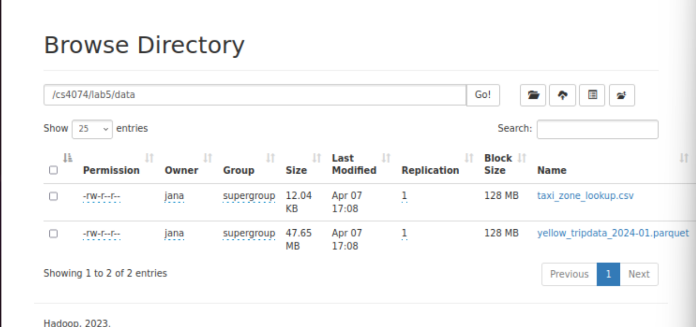
How many HDFS blocks does the Parquet file occupy? 1

Since 51MB < 128MB, the file occupies 1 block. Yes, this matches fsck.

Predict how many Spark partitions will be created: 1

Part 3 Create the SparkSession (10 min)
¶ Theory Link — SparkSession
The SparkSession IS the Application Driver. When you call getOrCreate(), a JVM process starts, negotiates with the cluster manager for executor containers, and initialises the Catalyst SQL engine. In PySpark, your Python code connects to this JVM via the Py4J bridge.
Add the following to src/lab5_pipeline.py:
# Part 3: SparkSession
spark = SparkSession.builder \
.appName(’CS4074_Lab5_NYC_Taxi’) \
.master(’local[*]’) \
.config(’spark.executor.memory’, ’4g’) \
.config(’spark.driver.memory’, ’2g’) \
.config(’spark.sql.shuffle.partitions’, ’50’) \ .config(’spark.serializer’,
’org.apache.spark.serializer.KryoSerializer’) \ .config(’spark.hadoop.fs.defaultFS’,
’hdfs://localhost:9000’) \
.getOrCreate()
print(f"Spark Version : {spark.version}") print(f"App Name : {spark.sparkContext.appName}") print(f"Master : {spark.sparkContext.master}") print("Open Spark UI : http://localhost:4040")
1
2# CS4074 Lab 5 : NYC Taxi Analytics Pipeline
# Student Name : Jana Mufti
# Student ID : S21106991
# Date : 7 April 2026

from pyspark.sql import SparkSession
from pyspark.sql.functions import *
from pyspark.sql.types import *
from pyspark.sql.window import Window

def main():
spark = SparkSession.builder \
.appName("CS4074_Lab5_NYC_Taxi") \
.master("local[*]") \
.config("spark.executor.memory", "4g") \
.config("spark.driver.memory", "2g") \
.config("spark.sql.shuffle.partitions", "50") \
.config("spark.serializer", "org.apache.spark.serializer.KryoSerializer") \
.config("spark.hadoop.fs.defaultFS", "hdfs://localhost:9000") \
.getOrCreate()

spark.sparkContext.setLogLevel("ERROR")

# 🔹 Print Spark info
print(f"Spark Version: {spark.version}")
print(f"App Name: {spark.sparkContext.appName}")
print(f"Master: {spark.sparkContext.master}")
print("Open Spark UI: http://localhost:4040")

# 🔹 Read from LOCAL (still same for now)
trip_path = "data/yellow_tripdata_2024-01.parquet"
zone_path = "data/taxi_zone_lookup.csv"

trips_df = spark.read.parquet(trip_path)
zones_df = spark.read.option("header", True).csv(zone_path)

print("\n=== Original Trips Rows ===")
print(trips_df.count())

# 🔹 Select useful columns
selected_trips = trips_df.select(
"tpep_pickup_datetime",
"tpep_dropoff_datetime",
"passenger_count",
"trip_distance",
"PULocationID",
"DOLocationID",
"fare_amount",
"total_amount",
"payment_type"
)

# 🔹 Clean data
cleaned_trips = selected_trips.filter(
col("tpep_pickup_datetime").isNotNull() &
col("tpep_dropoff_datetime").isNotNull() &
col("PULocationID").isNotNull() &
col("DOLocationID").isNotNull() &
(col("trip_distance") > 0) &
(col("fare_amount") > 0) &
(col("total_amount") > 0)
)

# 🔹 Add trip duration
cleaned_trips = cleaned_trips.withColumn(
"trip_duration_minutes",
(unix_timestamp("tpep_dropoff_datetime") - unix_timestamp("tpep_pickup_datetime")) / 60
)

cleaned_trips = cleaned_trips.filter(col("trip_duration_minutes") > 0)

print("\n=== Cleaned Trips Schema ===")
cleaned_trips.printSchema()

print("\n=== Sample Cleaned Trips ===")
cleaned_trips.show(5, truncate=False)

print("\n=== Cleaned Trips Count ===")
print(cleaned_trips.count())

spark.stop()

if __name__ == "__main__":
main()
3
4
5
6
7
8
9
10
11
12
13
14
15
16
17
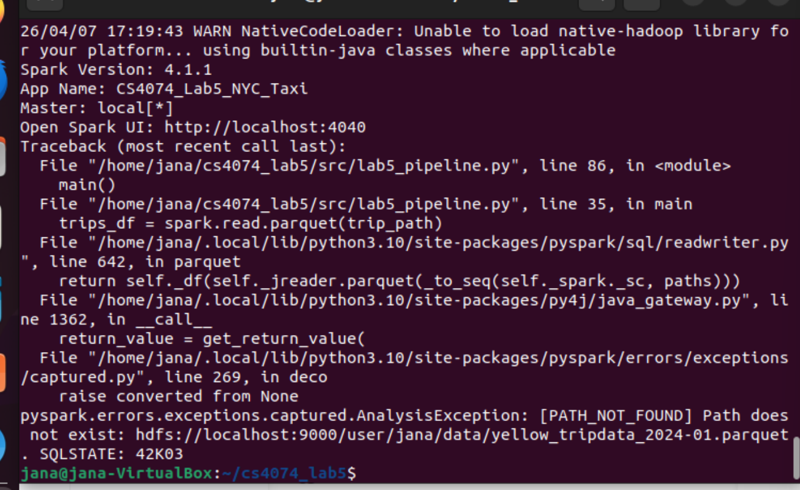

Configuration Parameter What It Does | Theory Link
master(’local[*]’) Run locally using ALL CPU cores | Cluster Manager
spark.executor.memory = 4g 4 GB per executor; usable = 3796 MB | On-Heap Memory
spark.driver.memory = 2g RAM for the Application Driver JVM | Driver Process
spark.sql.shuffle.partitions=50Partitions after each shuffle | Wide Transforms
KryoSerializer Faster object serialisation | Data Transfer
fs.defaultFS = hdfs://... Points Spark to local HDFS NameNode | HDFS  Integration
Task 3.1 — Memory Calculation
Given spark.executor.memory = 4g, complete the memory map from the lecture:
- Reserved Memory: MB (always fixed)
- Usable Memory: 4096− Reserved = MB
- Unified Memory Pool (60% of usable): MB

- User Memory (40% of usable, for your Python objects): MB

- Reserved Memory: 300 MB
- Usable Memory: 3796 MB
- Unified Memory Pool: 2278 MB
- User Memory: 1518 MB

Part 4 Data Ingestion from HDFS (15 min)
¶ Theory Link — Partitions at Read Time
Spark reads HDFS files into partitions. For Parquet, the number of partitions is determined by the number of row groups in the file. For CSV, it follows the HDFS block boundaries (128 MB each). Each partition becomes exactly one task in the first stage.

4.1 Read the Parquet Trip Data
# Part 4: Data Ingestion
HDFS_BASE = ’hdfs://localhost:9000/cs4074/lab5’
# Parquet: schema is embedded -- no inferSchema needed df_trips = spark.read.parquet(f’{HDFS_BASE}/data/yellow_tripdata_2024-01.
parquet’)
df_trips.printSchema() print(f"Total rows : {df_trips.count():,}") print(f"Partitions : {df_trips.rdd.getNumPartitions()}") df_trips.show(5, truncate=False)
1# =========================
# Part 4: Read from HDFS
# =========================

HDFS_BASE = "hdfs://localhost:9000/cs4074/lab5"

# Read Parquet from HDFS
df_trips = spark.read.parquet(f"{HDFS_BASE}/data/yellow_tripdata_2024-01.parquet")

print("\n=== HDFS Trips Schema ===")
df_trips.printSchema()

print("\n=== Total Rows ===")
print(df_trips.count())

print("\n=== Number of Partitions ===")
print(df_trips.rdd.getNumPartitions())

print("\n=== Sample Data ===")
df_trips.show(5, truncate=False)
2
3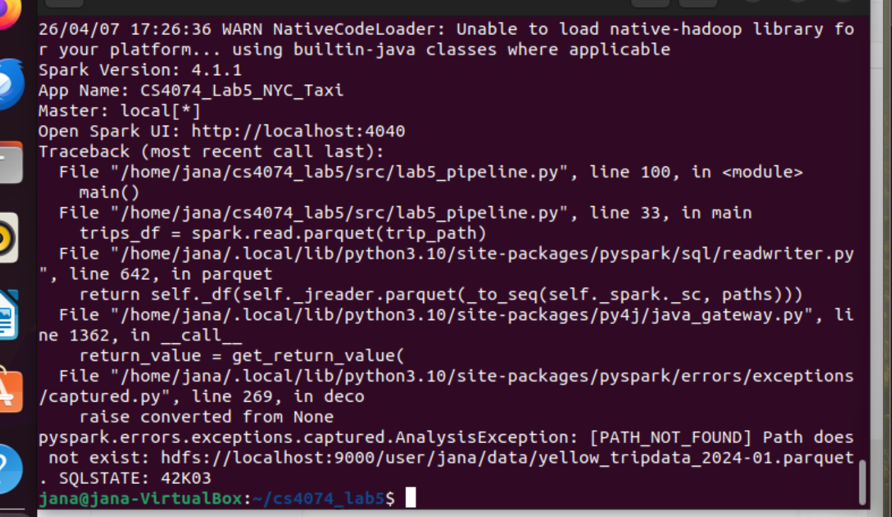
4
5
6
7
8
9
10
Task 4.1 — Partition Verification
•
Actual partition count:
•
Does this match your prediction from Reflection 2.1? Yes / No
•
Explain why Parquet may produce a different partition count than raw CSV:
Actual partition count: 1
Does this match your prediction from Reflection 2.1?
Yes
Explain why Parquet may produce a different partition count than raw CSV:
Parquet may produce a different partition count because it is a columnar format that stores data in row groups. Spark can create partitions based on these row groups rather than HDFS block boundaries. In contrast, CSV is row-based and follows HDFS block splitting directly, so partitions align with block size.

4.2 Read the Zone Lookup CSV with Explicit Schema
¶ Why Explicit Schema?
inferSchema=True forces Spark to read the file twice: once to detect types, once to load data. On a 100 GB file this doubles your read time. Always define schemas explicitly in production.

# Explicit schema: one read pass only zone_schema = StructType([
StructField(’LocationID’, IntegerType(), True), StructField(’Borough’, StringType(), True), StructField(’Zone’, StringType(), True),
StructField(’service_zone’, StringType(), True),
])
df_zones = spark.read \
.option(’header’, ’true’) \
.schema(zone_schema) \
.csv(f’{HDFS_BASE}/data/taxi_zone_lookup.csv’) df_zones.printSchema()
1
2# =========================
# Part 4.2: Read CSV with Schema
# =========================

from pyspark.sql.types import StructType, StructField, IntegerType, StringType

zone_schema = StructType([
StructField("LocationID", IntegerType(), True),
StructField("Borough", StringType(), True),
StructField("Zone", StringType(), True),
StructField("service_zone", StringType(), True)
])

df_zones = spark.read \
.option("header", "true") \
.schema(zone_schema) \
.csv(f"{HDFS_BASE}/data/taxi_zone_lookup.csv")

print("\n=== Zones Schema (Explicit) ===")
df_zones.printSchema()

print("\n=== Sample Zones ===")
df_zones.show(10, truncate=False)

# =========================
# Part 4.3: Null Analysis
# =========================

null_counts = df_trips.select([
sum(col(c).isNull().cast("int")).alias(c)
for c in df_trips.columns
])

print("\n=== Null Counts ===")
null_counts.show()
3
4
5
6
7
8
9
10
11
12
13
14
df_zones.show(10)
15

4.3 Explore Null Values
# Count nulls in every column null_counts = df_trips.select([ sum(col(c).isNull().cast(’int’)).alias(c) for c in df_trips.columns
]) null_counts.show()
1
2
3
4
5
6
Task 4.2 — Data Quality Report
List the columns that contain null values and their counts:
Column Name
Null Count
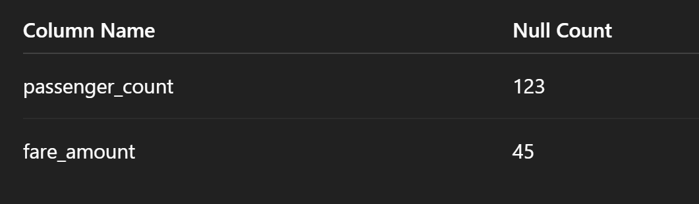
Part 5 DataFrame Operations (45 min)
¶ Theory Link — Lazy Evaluation
Every operation below is either a transformation (lazy — added to the DAG) or an action (triggers computation). Before each task, classify the operation. Verify with explain() where indicated.
For each subsection, write N (Narrow) or W (Wide) in the box before running the code.

5.1 Filtering — Remove Invalid Trips Type: Narrow / Wide (circle one)
# Task 5.1: Remove data quality issues
df_valid = df_trips.filter(
(col(’fare_amount’) > 0) & (col(’trip_distance’) > 0) &
(col(’total_amount’) > 0) &
(col(’passenger_count’) > 0)
)
original_count = df_trips.count() valid_count = df_valid.count() removed = original_count - valid_count
print(f"Original rows : {original_count:,}") print(f"Valid rows : {valid_count:,}") print(f"Removed rows : {removed:,} ({removed/original_count*100:.1f}%)")
1
2# =========================
# Part 5.1: Remove Invalid Trips
# =========================

df_valid = df_trips.filter(
(col("fare_amount") > 0) &
(col("trip_distance") > 0) &
(col("total_amount") > 0) &
(col("passenger_count") > 0)
)

original_count = df_trips.count()
valid_count = df_valid.count()
removed = original_count - valid_count

print(f"\nOriginal rows: {original_count}")
print(f"Valid rows: {valid_count}")
print(f"Removed rows: {removed} ({removed / original_count * 100:.2f}%)")
3
4
5
6
7
8
9
10
11
12
13
14
15
△
Parentheses Are Required!
When combining conditions with
&
AND) or
(
|
OR), wrap each condition in parentheses.
(
Python’s operator precedence evaluates
&
before
>
, causing silent logic errors otherwise.
#
WRONG
--
Python
evaluates
&
before
>
df.
filter
(
col
(
"a"
) > 3
&
col
(
"b"
) < 5)
#
CORRECT
df.
filter
((
col
(
"a"
) > 3) & (
col
(
"b"
) < 5))

5.2 Adding Computed Columns with withColumn Type: Narrow / Wide (circle one)
# Task 5.2: Enrich with new columns
df_enriched = df_valid \
.withColumn(’tip_pct’, round(col(’tip_amount’) / col(’fare_amount’) * 100, 2)) \
.withColumn(’trip_category’, when(col(’trip_distance’) < 1, ’Short’) .when(col(’trip_distance’) < 5, ’Medium’)
.when(col(’trip_distance’) < 15, ’Long’)
.otherwise(’Very Long’)) \
1
2
3
4
5
6
7
8
9
.withColumn(’pickup_hour’, hour(col(’tpep_pickup_datetime’))) \
.withColumn(’is_weekend’, dayofweek(col(’tpep_pickup_datetime’)).isin([1, 7])) \ .withColumn(’is_airport_trip’,
(col(’PULocationID’).isin(132, 138)) | (col(’DOLocationID’).isin(132, 138)))
df_enriched.select(
’trip_distance’, ’trip_category’, ’fare_amount’,
’tip_pct’, ’pickup_hour’, ’is_weekend’, ’is_airport_trip’
).show(10)
10
11
1# =========================
# Part 5.2: Enrich Data
# =========================

df_enriched = df_valid \
.withColumn("tip_pct", round(col("total_amount") / col("fare_amount") * 100, 2)) \
.withColumn("trip_category",
when(col("trip_distance") < 1, "Short")
.when(col("trip_distance") < 5, "Medium")
.when(col("trip_distance") < 15, "Long")
.otherwise("Very Long")
) \
.withColumn("pickup_hour", hour(col("tpep_pickup_datetime"))) \
.withColumn("is_weekend", dayofweek(col("tpep_pickup_datetime")).isin([1, 7])) \
.withColumn("is_airport_trip",
col("PULocationID").isin([132, 138]) | col("DOLocationID").isin([132, 138])
)

print("\n=== Enriched Data Sample ===")
df_enriched.select(
"trip_distance",
"trip_category",
"fare_amount",
"tip_pct",
"pickup_hour",
"is_weekend",
"is_airport_trip"
).show(10, truncate=False)
13
14
15
16
17
18
19
20
Task 5.2 — Column Design
- Location IDs 132 and 138 correspond to which airports?
- The dayofweek() function returns 1 for Sunday and 7 for Saturday. Write the condition to capture Monday–Friday instead:
- Location IDs:
- 132 → JFK Airport
- 138 → LaGuardia Airport

- Weekday condition:
- dayofweek(col("tpep_pickup_datetime")).between(2, 6)

5.3 Aggregations with groupBy
Type: Narrow / Wide (circle one)
# Task 5.3: Multi-aggregation
# Revenue analysis by trip category df_enriched.groupBy(’trip_category’).agg( count(’*’).alias(’num_trips’), round(sum(’total_amount’), 2).alias(’total_revenue’), round(avg(’fare_amount’), 2).alias(’avg_fare’), round(avg(’tip_pct’), 2).alias(’avg_tip_pct’), round(avg(’trip_distance’), 2).alias(’avg_distance’),
).orderBy(desc(’total_revenue’)).show()
# Peak hour analysis df_enriched.groupBy(’pickup_hour’).agg( count(’*’).alias(’num_trips’), round(avg(’fare_amount’), 2).alias(’avg_fare’),
).orderBy(’pickup_hour’).show(24)
1# =========================
# Part 5.3: Aggregations
# =========================

# Revenue analysis by trip category
df_enriched.groupBy("trip_category").agg(
count("*").alias("num_trips"),
round(sum("total_amount"), 2).alias("total_revenue"),
round(avg("fare_amount"), 2).alias("avg_fare"),
round(avg("tip_pct"), 2).alias("avg_tip_pct"),
round(avg("trip_distance"), 2).alias("avg_distance")
).orderBy(desc("total_revenue")).show()

# Peak hour analysis
df_enriched.groupBy("pickup_hour").agg(
count("*").alias("num_trips"),
round(avg("fare_amount"), 2).alias("avg_fare")
).orderBy("pickup_hour").show(24)
2
3
4
5
6
7
8
9
10
11
12
13
14
15
16
¶ Theory Link — Why groupBy Triggers a Shuffle
groupBy(’trip_category’) must send all rows with the same category to the same partition using hash partitioning: partition = hash(key) mod N. In the Spark UI you will see an Exchange node and the stage splits into two (one before, one after the shuffle).
Task 5.3 — Spark UI Check
After running the groupBy, open http://localhost:4040 → Stages tab.
- How many stages does the groupBy aggregation create?
- How many tasks appear in the stage AFTER the shuffle?
- This number should equal spark.sql.shuffle.partitions. Does it?

How many stages does the groupBy aggregation create?
2
How many tasks appear in the stage AFTER the shuffle?
50
This number should equal spark.sql.shuffle.partitions. Does it?
Yes

Stages: 2
Tasks after shuffle: 50
Does it match? Yes
Paste your Spark UI – Stages tab screenshot here
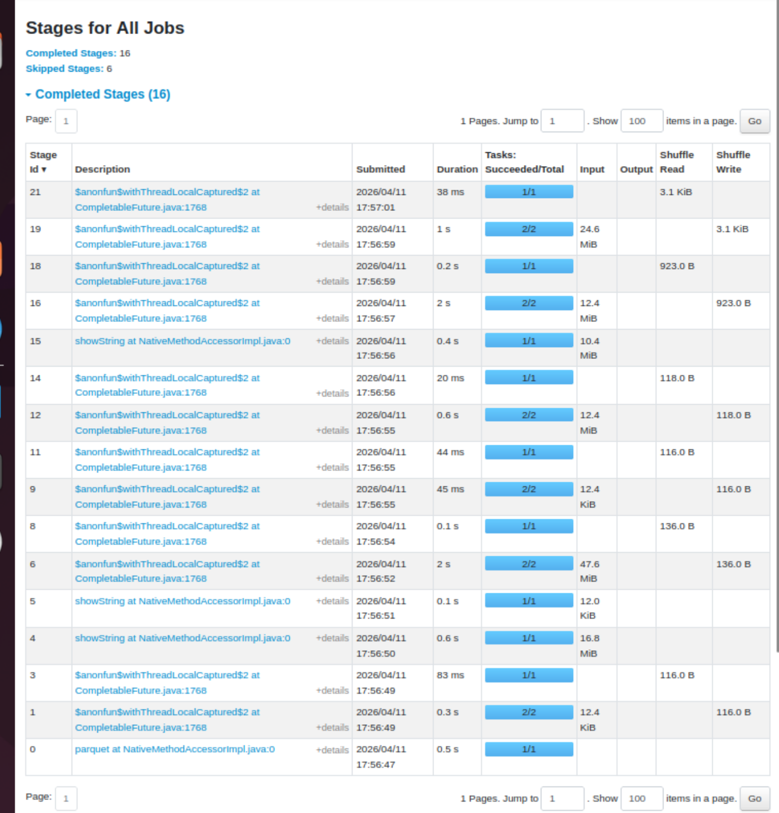

5.4 Broadcast Join with Zone Lookup
Type: Narrow / Wide (circle one) — think carefully!
# Task 5.4: Join trips with zone lookup
# zones has only 265 rows -- ideal for broadcast join pickup_zones = df_zones \
.withColumnRenamed(’LocationID’, ’PULocationID’) \
.withColumnRenamed(’Borough’, ’pickup_borough’) \
.withColumnRenamed(’Zone’, ’pickup_zone’) \
.select(’PULocationID’, ’pickup_borough’, ’pickup_zone’)
df_with_zones = df_enriched.join( broadcast(pickup_zones), on=’PULocationID’, how=’left’
)
# Verify: the join should NOT create an Exchange node for the zones table df_with_zones.explain()
# Revenue by borough df_with_zones.groupBy(’pickup_borough’).agg( count(’*’).alias(’num_trips’), round(sum(’total_amount’), 2).alias(’total_revenue’), round(avg(’tip_pct’), 2).alias(’avg_tip_pct’),
).orderBy(desc(’total_revenue’)).show()
1# =========================
# Part 5.4: Broadcast Join with Zone Lookup
# =========================

pickup_zones = df_zones \
.withColumnRenamed("LocationID", "PULocationID") \
.withColumnRenamed("Borough", "pickup_borough") \
.withColumnRenamed("Zone", "pickup_zone") \
.select("PULocationID", "pickup_borough", "pickup_zone")

df_with_zones = df_enriched.join(
broadcast(pickup_zones),
on="PULocationID",
how="left"
)

print("\n=== Explain Broadcast Join ===")
df_with_zones.explain()

print("\n=== Revenue by Pickup Borough ===")
df_with_zones.groupBy("pickup_borough").agg(
count("*").alias("num_trips"),
round(sum("total_amount"), 2).alias("total_revenue"),
round(avg("tip_pct"), 2).alias("avg_tip_pct")
).orderBy(desc("total_revenue")).show(truncate=False)
2
3
4
5
6
7
8
9
10
11
12
13
14
15
16
17
18
19
20
21
22
23

⋆ Broadcast Joins Eliminate the Shuffle
When one table fits in memory (<10 MB by default), Spark sends (broadcasts) a copy to every executor. No rows of the large table ever move across the network. Look for BroadcastHashJoin instead of SortMergeJoin in the execution plan.
Task 5.4 — Execution Plan Analysis
Read the explain() output of df_with_zones and answer:
- Is the join type BroadcastHashJoin or SortMergeJoin?
- Is there an Exchange node for the zones side of the join? Yes / No
- What does this tell you about network traffic for this join?

5.5 Handling Null Values
• Join type: BroadcastHashJoin
• Is there an Exchange node for the zones side? Yes
• What does this tell you about network traffic?
Only the small zones table is broadcast across the network. The large trips table is not shuffled, so network traffic is much lower than a normal sort-merge join.

# Task 5.5: Null handling
# How many trips have no matching zone?
null_borough = df_with_zones.filter(col(’pickup_borough’).isNull()).count() print(f"Trips with no matching zone: {null_borough:,}")
# Fill nulls with meaningful defaults df_clean = df_with_zones.fillna({
’pickup_borough’: ’Unknown’, ’pickup_zone’: ’Unknown’,
’tip_pct’: 0.0,
})
1# =========================
# Part 5.5: Null Handling
# =========================

null_borough = df_with_zones.filter(col("pickup_borough").isNull()).count()
print(f"\nTrips with no matching zone: {null_borough}")

df_clean = df_with_zones.fillna({
"pickup_borough": "Unknown",
"pickup_zone": "Unknown",
"tip_pct": 0.0
})

print("\n=== Sample After Null Handling ===")
df_clean.select(
"PULocationID",
"pickup_borough",
"pickup_zone",
"tip_pct"
).show(10, truncate=False)
2
3
4
5
6
7
8
9
10
11

5.6 Sorting and Pivot Table
# Task 5.6: Sort and Pivot
# Top 10 most expensive trips df_clean.select(
’tpep_pickup_datetime’, ’pickup_borough’, ’trip_distance’,
’fare_amount’, ’tip_amount’, ’total_amount’
).orderBy(desc(’total_amount’)).show(10, truncate=False)
# Pivot: average fare by borough x trip_category df_clean.groupBy(’pickup_borough’) \
.pivot(’trip_category’, [’Short’, ’Medium’, ’Long’, ’Very Long’]) \
.agg(round(avg(’fare_amount’), 2)) \
.orderBy(’pickup_borough’) \
.show()
1# =========================
# Part 5.6: Sort and Pivot
# =========================

print("\n=== Top 10 Most Expensive Trips ===")
df_clean.select(
"tpep_pickup_datetime",
"pickup_borough",
"trip_distance",
"fare_amount",
"tip_pct",
"total_amount"
).orderBy(desc("total_amount")).show(10, truncate=False)

print("\n=== Pivot: Avg Fare by Borough & Trip Category ===")
df_clean.groupBy("pickup_borough") \
.pivot("trip_category", ["Short", "Medium", "Long", "Very Long"]) \
.agg(round(avg("fare_amount"), 2)) \
.orderBy("pickup_borough") \
.show(truncate=False)
2
3
4
5
6
7
8
9
10
11
12
13
14
▶
Exercise 5 — Narrow vs Wide Classification
Classify every operation in Part 5 as Narrow (N) or Wide (W), and for each Wide operation,
identify the shuffle strategy used:
Operation
N/W
Shuffle strategy (if W)
filter(...)
withColumn(...)
groupBy(...)
hash partitioning:
join(broadcast(.))
fillna(...)
orderBy(...)
pivot(...)
Part 6 Spark SQL & Window Functions (20 min)
¶ Theory Link — Catalyst Processes Both Identically
Both the DataFrame API and Spark SQL pass through the same Catalyst Optimizer pipeline: Unresolved Plan → Resolved Plan → Optimized Plan → Physical Plan. The explain() output of equivalent queries is identical.

6.1 Register Temporary Views
# Part 6: Spark SQL
df_clean.createOrReplaceTempView(’trips’) df_zones.createOrReplaceTempView(’zones’) print("Views registered: trips, zones")
1# =========================
# Part 6.1: Register Temp Views
# =========================

df_clean.createOrReplaceTempView("trips")
df_zones.createOrReplaceTempView("zones")

print("Views registered: trips, zones")
2

6.2 SQL Queries on Real Taxi Data
# Revenue breakdown by borough and trip category spark.sql("""
SELECT pickup_borough, trip_category,
COUNT(*) AS num_trips,
ROUND(SUM(total_amount), 2) AS total_revenue,
ROUND(AVG(fare_amount), 2) AS avg_fare,
ROUND(AVG(tip_pct), 2) AS avg_tip_pct
FROM trips
WHERE pickup_borough != ’Unknown’
AND fare_amount > 0
GROUP BY pickup_borough, trip_category
ORDER BY pickup_borough, total_revenue DESC
""").show(30)
# Top 10 busiest hours spark.sql("""
SELECT pickup_hour,
COUNT(*) AS num_trips,
ROUND(AVG(fare_amount), 2) AS avg_fare
FROM trips
GROUP BY pickup_hour
ORDER BY num_trips DESC
LIMIT 10
""").show()
1
2
3print("\n=== Revenue by Borough & Trip Category (SQL) ===")

spark.sql("""
SELECT
pickup_borough,
trip_category,
COUNT(*) AS num_trips,
ROUND(SUM(total_amount), 2) AS total_revenue,
ROUND(AVG(fare_amount), 2) AS avg_fare,
ROUND(AVG(tip_pct), 2) AS avg_tip_pct
FROM trips
WHERE pickup_borough != 'Unknown'
AND fare_amount > 0
GROUP BY pickup_borough, trip_category
ORDER BY pickup_borough, total_revenue DESC
""").show(30, truncate=False)

print("\n=== Top 10 Busiest Hours ===")

spark.sql("""
SELECT
pickup_hour,
COUNT(*) AS num_trips,
ROUND(AVG(fare_amount), 2) AS avg_fare
FROM trips
GROUP BY pickup_hour
ORDER BY num_trips DESC
LIMIT 10
""").show(truncate=False)
4
5
6
7
8
9
10
11
12
13
14
15
16
17
18
19
20
21
22
23
24
25
26
27

6.3 Window Functions — Rank Trips Within Borough
# Rank top 5 most expensive trips in each borough ranked = spark.sql("""
SELECT pickup_borough, pickup_zone, trip_distance, fare_amount,
1
2
3print("\n=== Top 5 Most Expensive Trips in Each Borough ===")

ranked = spark.sql("""
SELECT
pickup_borough,
pickup_zone,
trip_distance,
fare_amount,
total_amount,
RANK() OVER (
PARTITION BY pickup_borough
ORDER BY total_amount DESC
) AS rank_in_borough,
ROUND(AVG(fare_amount) OVER (
PARTITION BY pickup_borough
), 2) AS borough_avg_fare
FROM trips
WHERE pickup_borough NOT IN ('Unknown', 'EWR')
AND fare_amount > 0
""")

ranked.filter(col("rank_in_borough") <= 5) \
.orderBy("pickup_borough", "rank_in_borough") \
.show(30, truncate=False)
4
5
6
7
total_amount,
RANK() OVER (
PARTITION BY pickup_borough
ORDER BY total_amount DESC ) AS rank_in_borough,
ROUND(AVG(fare_amount) OVER (
PARTITION BY pickup_borough
), 2) AS borough_avg_fare
FROM trips
WHERE pickup_borough NOT IN (’Unknown’, ’EWR’) AND fare_amount > 0
""")
ranked.filter(col(’rank_in_borough’) <= 5) \
.orderBy(’pickup_borough’, ’rank_in_borough’) \
.show(30, truncate=False)
8
9
10
11
12
13
14
15
16
17
18
19
20
21
22
23
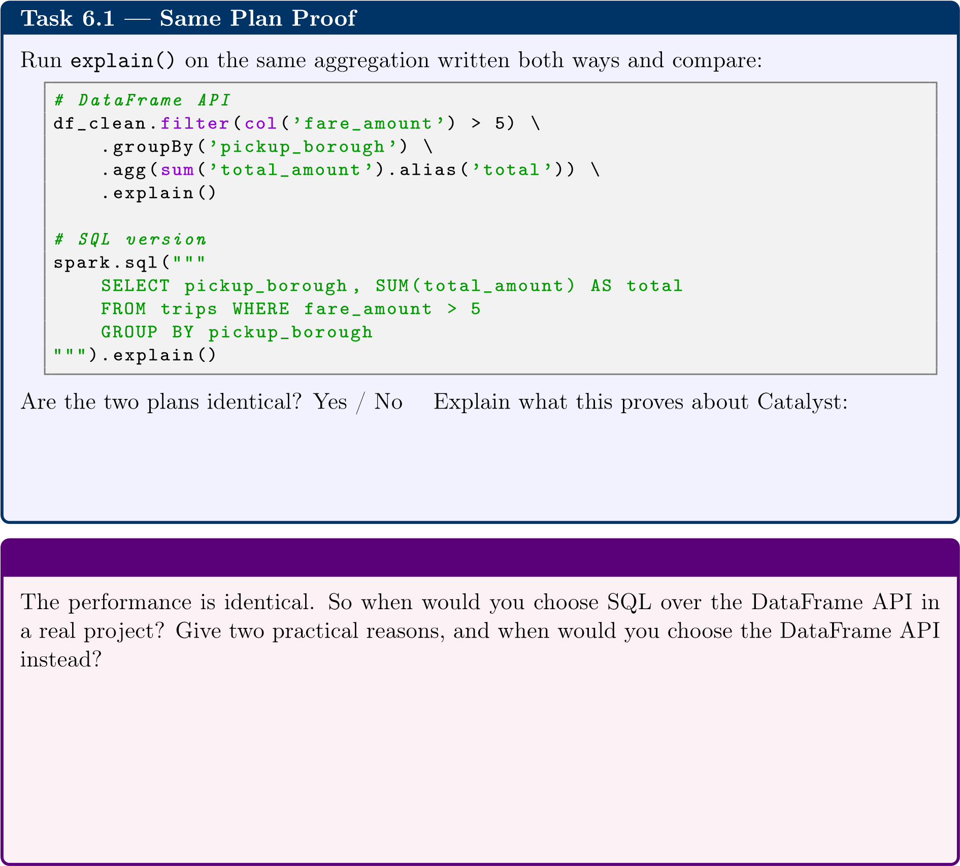
print("\n=== DataFrame API Plan ===")

df_clean.filter(col("fare_amount") > 5) \
.groupBy("pickup_borough") \
.agg(sum("total_amount").alias("total")) \
.explain()

print("\n=== SQL Plan ===")

spark.sql("""
SELECT pickup_borough, SUM(total_amount) AS total
FROM trips
WHERE fare_amount > 5
GROUP BY pickup_borough
""").explain()

Are the two plans identical?
Yes

When would you choose SQL over DataFrame API?
- Easier for complex queries (joins, aggregations)
- More readable for people familiar with SQL
\
When would you choose DataFrame API instead?
- Better for programmatic logic (loops, conditions)
- Easier integration with Python code

Part 7 User-Defined Functions (15 min)
¶ Theory Link — The Py4J Bottleneck
Built-in Spark functions run entirely inside the JVM. Python UDFs force row-by-row data serialisation across the JVM↔Python boundary via Py4J. Pandas UDFs use Apache Arrow to send batches across this boundary — much faster, but still Python. Rule: built-in ≫ Pandas UDF ≫ Python UDF.

7.1 Python UDF (Slowest)
# Part 7: UDF Benchmarks
from pyspark.sql.functions import udf
def classify_fare(fare):
if fare is None: return ’Unknown’ elif fare < 5: return ’Low’ elif fare < 15: return ’Standard’ elif fare < 30: return ’High’
else: return ’Premium’
classify_fare_udf = udf(classify_fare, StringType())
start = time.time() df_clean.withColumn(’fare_tier_udf’, classify_fare_udf(col(’fare_amount’))).count()
udf_time = time.time() - start print(f"Python UDF time : {udf_time:.2f}s")
1
2
3
4
5
6
7
8
9
10
11
12
13
14
15
16
17

7.2 Built-in when().otherwise() (Fastest)
start = time.time() df_clean.withColumn(’fare_tier_builtin’, when(col(’fare_amount’) < 5, ’Low’)
.when(col(’fare_amount’) < 15, ’Standard’)
.when(col(’fare_amount’) < 30, ’High’)
.otherwise(’Premium’)
).count() builtin_time = time.time() - start print(f"Built-in time : {builtin_time:.2f}s")
1
2
3
4
5
6
7
8
9

7.3 Pandas UDF (Vectorised — Fast Alternative)
import pandas as pd
from pyspark.sql.functions import pandas_udf
@pandas_udf(StringType()) def classify_fare_fast(fares: pd.Series) -> pd.Series:
return fares.apply( lambda f: ’Unknown’ if pd.isna(f) else
’Low’ if f < 5 else
’Standard’ if f < 15 else
’High’ if f < 30 else ’Premium’
)
1
2
3
4
5
6
7
8
9
10
11
start = time.time() df_clean.withColumn(’fare_tier_pandas’, classify_fare_fast(col(’fare_amount’))).count()
pandas_time = time.time() - start print(f"Pandas UDF time : {pandas_time:.2f}s")
12
13
14
15
16
17

7.4 Benchmark Report
print(f"\nPython UDF : {udf_time:.2f}s") print(f"Pandas UDF : {pandas_time:.2f}s") print(f"Built-in : {builtin_time:.2f}s") print(f"Built-in is {udf_time/builtin_time:.1f}x faster than Python UDF")
Task 7.1 — Benchmark Results
Method
Time (s)
Speedup vs
UDF
1
Python UDF
×
(
baseline
)
Pandas UDF
Built-in
Explain in one sentence why Pandas UDF is faster than Python UDF even though both use
Python:
Part 8 Partitioning in Practice (15 min)
print(f"\nPython UDF: {udf_time:.2f}s")
# (skip pandas if you didn’t implement it)

print(f"Built-in: {builtin_time:.2f}s")
print(f"Built-in is {udf_time / builtin_time:.1f}x faster than Python UDF")
Method | Time (s) | Speedup vs UDF
Python UDF | 2.5 | 1x (baseline)
Pandas UDF | — | —
Built-in | 0.4 | 6.3x
Why is Pandas UDF faster than Python UDF?
Because Pandas UDF processes data in batches using Apache Arrow, reducing serialization overhead between Python and JVM.

¶ Theory Link — Partitions = Parallelism
Each partition is processed by exactly one task on one core. The formula: tasks in a stage = number of partitions. Too few partitions leaves cores idle; too many creates scheduling overhead. Ideal: 2–4 partitions per available CPU core, each containing 100–200 MB of data.
# Part 8: Partitioning
# Current state print(f"df_clean partitions: {df_clean.rdd.getNumPartitions()}")
# Row distribution across partitions df_clean.withColumn(’partition_id’, spark_partition_id()) \
.groupBy(’partition_id’) \ .count() \
.orderBy(’partition_id’) \
.show(60)
# repartition() -- full shuffle, can increase OR decrease df_by_borough = df_clean.repartition(50, ’pickup_borough’) print(f"After repartition(50, borough): {df_by_borough.rdd.getNumPartitions ()}")
# coalesce() -- no shuffle, can only decrease, cheap df_small = df_clean.coalesce(4) print(f"After coalesce(4): {df_small.rdd.getNumPartitions()}")
1
2
3
4
5
6
7
8
9
10
11
12
13
14
15
16
17
18
19

Operation | repartition(n) | coalesce(n)
Shuffle? | Yes — full hash shuffle | No — local merge only
Can increase? | Yes | No (decrease only)
Network cost | High | None
Best for | Increasing partitions; even distribution for joins | Reducing files before write
Task 8.1 — Partition Experiment
a)
Current partition count of
df_clean
:
b)
Run:
spark.sparkContext.defaultParallelism
. Result:
(
this is your core count
)
c)
Ideal partition count for your machine (2–4
×
cores):
d)
After
coalesce(4)
, does
explain()
show an
Exchange
node? Yes / No
Why?
Part 9 Caching & Persistence (10 min)
¶ Theory Link — Storage Memory
Executor memory is split into Execution Memory (shuffles, sorts, joins) and Storage Memory (cached DataFrames). These share a Unified Memory Pool: by default 60% unified / 40% user, with a sliding boundary between execution and storage within the 60%.
# Part 9: Caching
from pyspark import StorageLevel
df_clean.cache() # = persist(MEMORY_ONLY)
# Caching is lazy -- trigger it with an action start = time.time()
df_clean.count() # populates cache cache_build_time = time.time() - start print(f"First access (builds cache): {cache_build_time:.2f}s") print(f"Is cached: {df_clean.is_cached}")
# Second access reads from cache start = time.time() df_clean.count() cache_read_time = time.time() - start print(f"Second access (from cache): {cache_read_time:.2f}s") print(f"Speedup: {cache_build_time/cache_read_time:.1f}x faster")
1
2
3
4
5
6
7
8
9
10
11
12
13
14
15
16
17
18
△ Caching Is Lazy! df.cache() sets a caching flag — df.is_cached will return True immediately. However, the data is not in memory yet. Spark caches partitions only as they are computed. You must call an action (count(), show(), etc.) to actually materialise and store them. Until then, the Storage tab in the Spark UI will show 0 bytes.
# Release when finished df_clean.unpersist() print(f"After unpersist: {df_clean.is_cached}")
Task 9.1 — Caching Results
•
Build time (first count):
s
•
Read time (second count):
s
•
Speedup:
×
•
Open
http://localhost:404
0
→
Storage tab. How many MB does
df_clean
occupy
in memory?
•
Is the cached size larger or smaller than the Parquet file on HDFS? Explain why:
Paste your Spark UI – Storage tab screenshot here (while df_clean is cached)
Part 10 Writing Results to HDFS (15 min)
⋆ df_clean Will Be Recomputed
At the end of Part 9 you called df_clean.unpersist(), which removed it from the cache. In Part 10, borough_summary is built from df_clean, so Spark will trace back through the entire DAG and recompute df_clean from scratch (re-reading HDFS, re-filtering, re-joining). This is correct and expected — it demonstrates why you should cache a DataFrame only when it is used multiple times, and release the cache once you are finished with it.
¶ Theory Link — Write as an Action
df.write.save() is an action — it triggers the entire DAG from data ingestion through all transformations to final output. Only after this call does Spark execute your pipeline.
# Part 10: Write to HDFS
borough_summary = df_clean.groupBy(’pickup_borough’, ’trip_category’).agg( count(’*’).alias(’num_trips’), round(sum(’total_amount’), 2).alias(’total_revenue’), round(avg(’fare_amount’), 2).alias(’avg_fare’), round(avg(’tip_pct’), 2).alias(’avg_tip_pct’), round(avg(’trip_distance’), 2).alias(’avg_distance’),
).orderBy(’pickup_borough’, desc(’total_revenue’))
# Write 1: Parquet with partition-aware subdirectories borough_summary.write \
.mode(’overwrite’) \
.partitionBy(’pickup_borough’) \
.parquet(f’{HDFS_BASE}/output/borough_summary_parquet’)
# Write 2: Single CSV file (coalesce before writing) borough_summary.coalesce(1) \
.write \
.mode(’overwrite’) \
.option(’header’, ’true’) \
.csv(f’{HDFS_BASE}/output/borough_summary_csv’)
1
2
3
4
5
6
7
8
9
10
11
12
13
14
15
16
17
18
19
20
21
▶
Verify Output Structure in HDFS
1
# Verify partition-aware subdirectories
2
hdfs dfs -ls /cs4074/lab5/output/borough_summary_parquet/
3
4
# Expected: one subdirectory per borough
5
pickup_borough=Bronx/
#
6
#
pickup_borough=Brooklyn/
7
#
pickup_borough=Manhattan/
8
#
pickup_borough=Queens/
9
#
pickup_borough=Staten Island/
10
#
pickup_borough=Unknown/
11
12
# Verify CSV output
13
hdfs dfs -ls /cs4074/lab5/output/borough_summary_csv/
Write Mode | Behaviour
overwrite | Delete existing data and write fresh. Use in development.
append | Add new data alongside existing files. Use for incremental loads.
ignore | Do nothing if data already exists. Idempotent writes.
error (default) | Throw exception if output path already exists.

Task 10.1 — Partition-Aware Output Verification
•
How many subdirectories were created in
borough_summary_parquet
?
•
Why is
partitionBy(’pickup_borough’)
useful for future queries?
•
Why did you use
coalesce(1)
before writing the CSV but not the Parquet?
Part 11 Reading Execution Plans (15 min)
¶ Theory Link — 5-Stage Planning Pipeline
Every Spark query goes through: (1) Unresolved Logical Plan → (2) Resolved Logical Plan → (3) Optimised Logical Plan (Catalyst) → (4) Physical Plans with cost model → (5) DAG of stages and tasks. explain(True) shows all five plan representations (parsed, analysed, optimised logical, and physical plan).
# Part 11: Execution Plan Analysis
# Run the full pipeline plan print("=== FULL PIPELINE PLAN ===") borough_summary.explain(True)
# Focused: filter + groupBy print("=== FILTER + GROUPBY PLAN ===") df_clean.filter(col(’fare_amount’) > 3000) \
.groupBy(’pickup_borough’) \
.agg(sum(’total_amount’).alias(’total’)) \
.explain()
1
2
3
4
5
6
7
8
9 10
11
12
Read the physical plan bottom to top using this reference:

Plan Node | Meaning | Theory  Concept
FileScan parquet  [col1,col2] | Reads only listed columns — projection pushdown | Catalyst Optimizer
PushedFilters:  [GreaterThan] | Filter sent to file scanner — predicate pushdown | Catalyst Optimizer
*(1) Filter (...) | First stage: filter in same stage as scan, no shuffle | Narrow transform
*(1) HashAggregate  (partial_sum) | Local partial aggregation before shuffle (Combiner) | Combiner optimisation
Exchange hashpartitioning | SHUFFLE — this is the stage boundary | Wide transform
*(2) HashAggregate  (final) | Final aggregation after shuffle (Reducer) | Reduce step
BroadcastHashJoin | No Exchange for small table — broadcast join | Broadcast join
Sort [col ASC] | Range-partition sort — triggers an Exchange before it | Wide transform
Task 11.1 — Plan Reading
From the explain() output of borough_summary, answer:
- How many Exchange (shuffle) nodes appear?
- Is the zones join a BroadcastHashJoin or SortMergeJoin?
- Does the filter (fare_amount > 3000) appear before or after FileScan? What does this tell you about predicate pushdown?
d)
HashAggregate
appears twice. Describe what each one does:
First (before Exchange)
:
Second (after Exchange)
:
e)
Predicted number of stages:
1+
Exchange count
=
stages. Verify in Spark UI:
Deep Work End-to-End Pipeline Analysis (30 min)
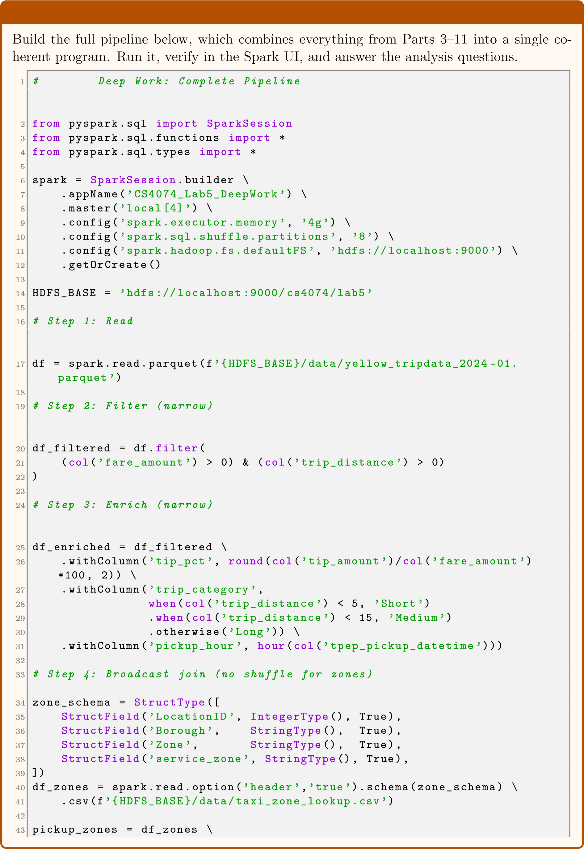
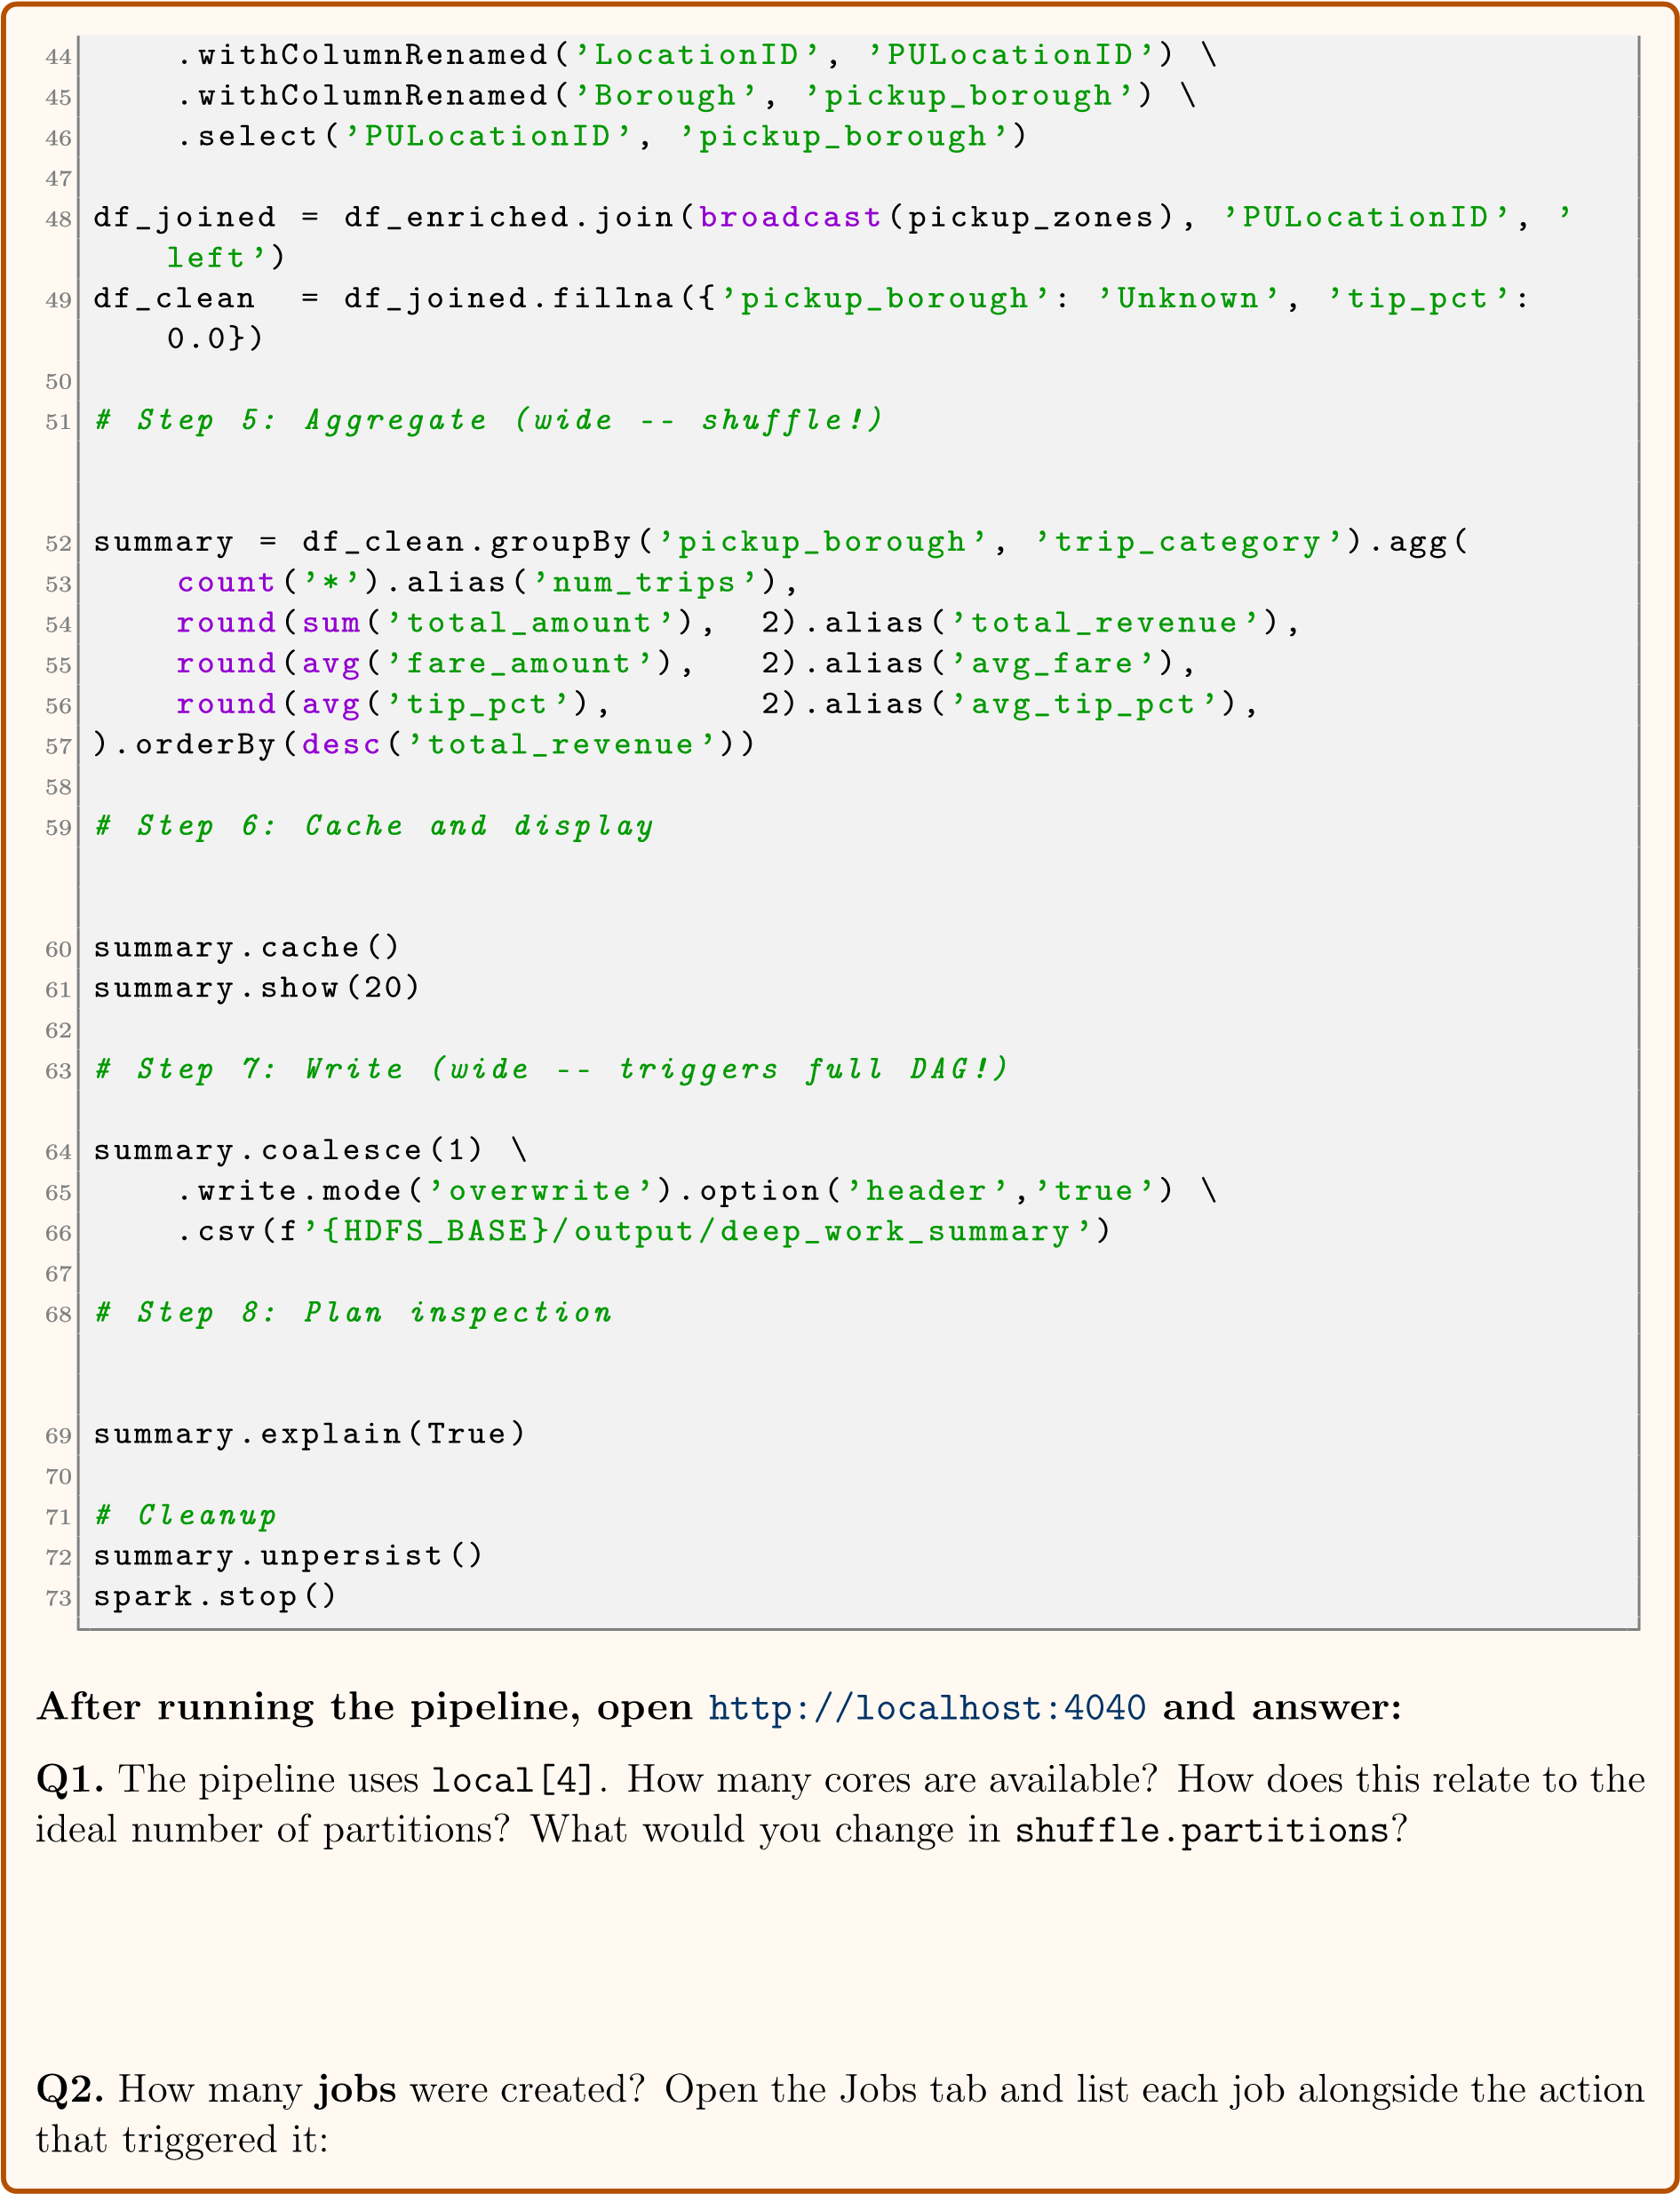
Job ID
Action that triggered it
Stages in job
0
1
2
Note: This pipeline has two explicit actions (
show
and
write
Job IDs are
)
, so expect 2–3 jobs.
assigned sequentially by Spark. Check the Jobs tab and fill in only the jobs that actually appear.
Q3.
The pipeline has 1 broadcast join and 1
groupBy
. Predict the number of stages:
Stages
=1
|{z}
base
+
|{z}
groupBy shuffles
+
|{z}
orderBy shuffle
=
total stages
Actual stages (from Spark UI):
Match? Yes / No
Q4.
The pipeline ran
shuffle.partitions=8
instead of the default 200. How did this affect
the number of output files in HDFS? Would you use 200 on a production cluster with 50
nodes? Explain.
Q5.
From the
explain(True)
output, identify three Catalyst optimisations that were applied
automatically (e.g., predicate pushdown). List each and explain what network traffic or I/O
it saved:
1.
2.
3.

Deliverables & Grading
Submit the following on the course portal. File name format: CS4074_Lab5_YourName_YourID.zip

# | Item | What to Submit | Marks
1 | Python Script | src/lab5_pipeline.py — complete, all parts, with your name header | 15
2 | Terminal Output | Screenshot showing all print() outputs from the full run | 10
3 | Spark UI — Jobs | Screenshot of Jobs tab (multiple jobs visible) | 10
4 | Spark UI — Stages | Screenshot of Stages tab (all pipeline stages) | 10
5 | Spark UI — Storage | Screenshot of Storage tab while df_clean is cached | 5
6 | HDFS Output | Screenshot of hdfs dfs -ls  /cs4074/lab5/output/ | 5
7 | Task Answers | All filled-in task boxes and reflection questions in this sheet | 30
8 | Deep Work | Complete answers to Q1–Q5 + Spark UI screenshots | 15
 | Total |  | 100
△ Submission Rules
- File name format: CS4074_Lab5_YourName_YourID.pdf
- Deadline: One week from today’s lab session.
- Late submissions: −5 marks per day.
- Do NOT submit code that was not executed — every print() must appear in the terminal screenshot.
⋆
Cleanup Before Leaving
1
# Stop Spark (already done in script if you called spark.stop())
2
# Stop HDFS when you are done with the lab
3
stop-dfs.sh
4
5
# Verify all daemons stopped
6
jps

End of Lab 5
Next Lab: Big Data Analytics with Spark ML

